References

**Topic: Medical Health Care Hub**

**Driving Question:** How can we develop a free online platform which supports in building community resilience through integrated wellness resources for Myanmar?

**Essential Question:** How can we create a healthcare website which effectively guides the Myanmar community in accessing health tips and treatments' info to improve their health's outcomes?

Aim of Website: **to spread information about the symptoms, illness diseases (Update one and the old one) and also make a guide or tips and even some digital treatments from doctors for the visitors of our websites.**

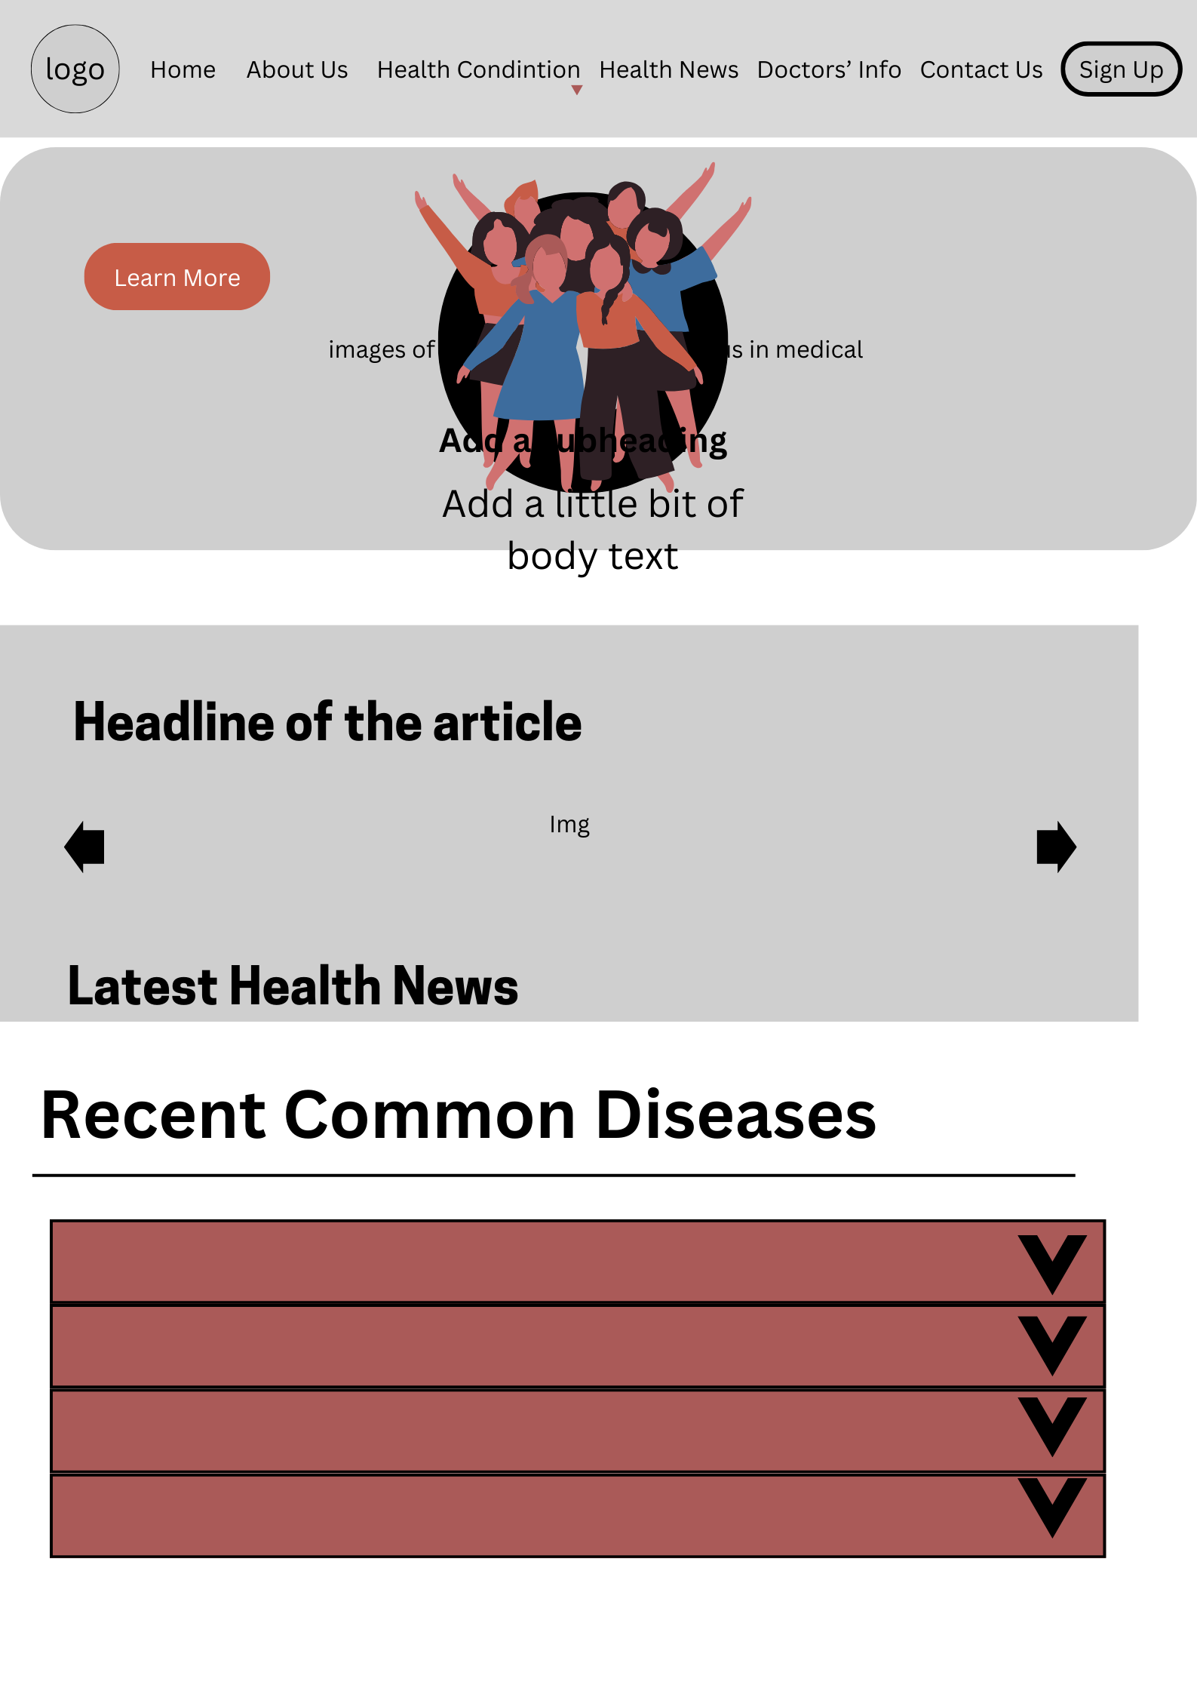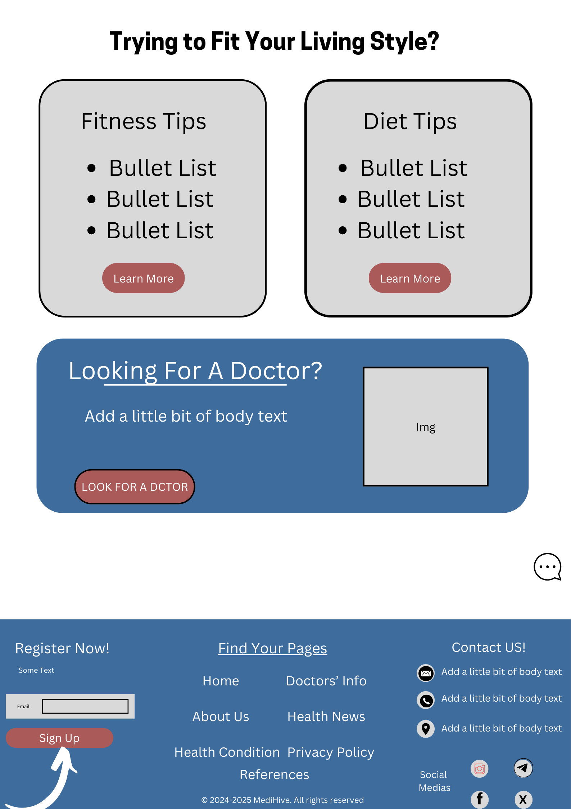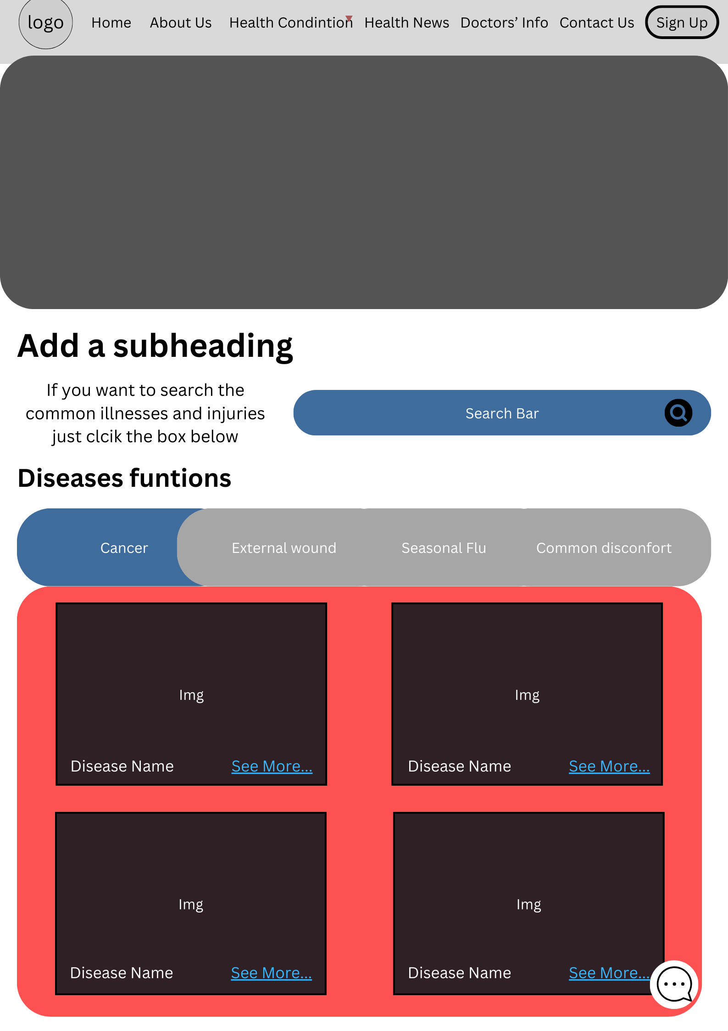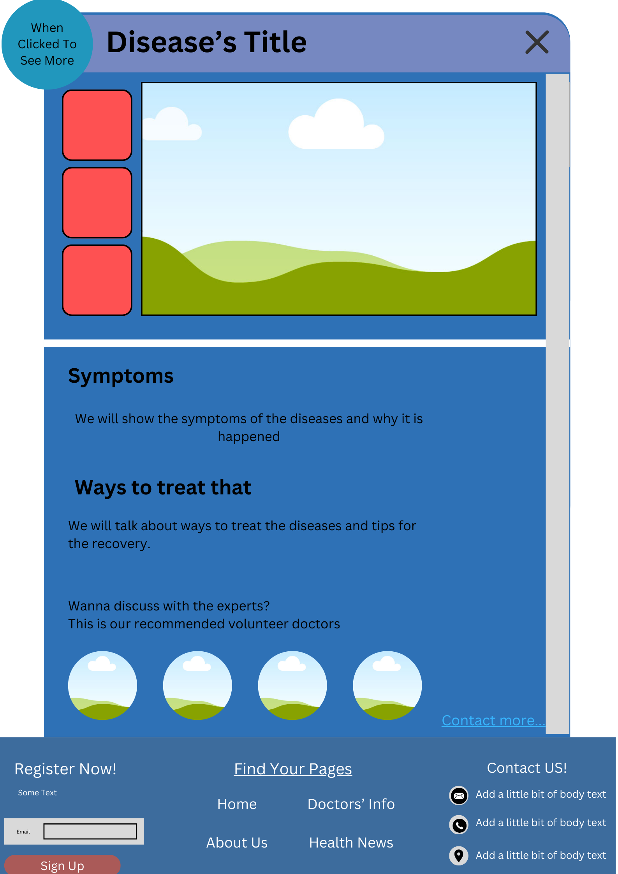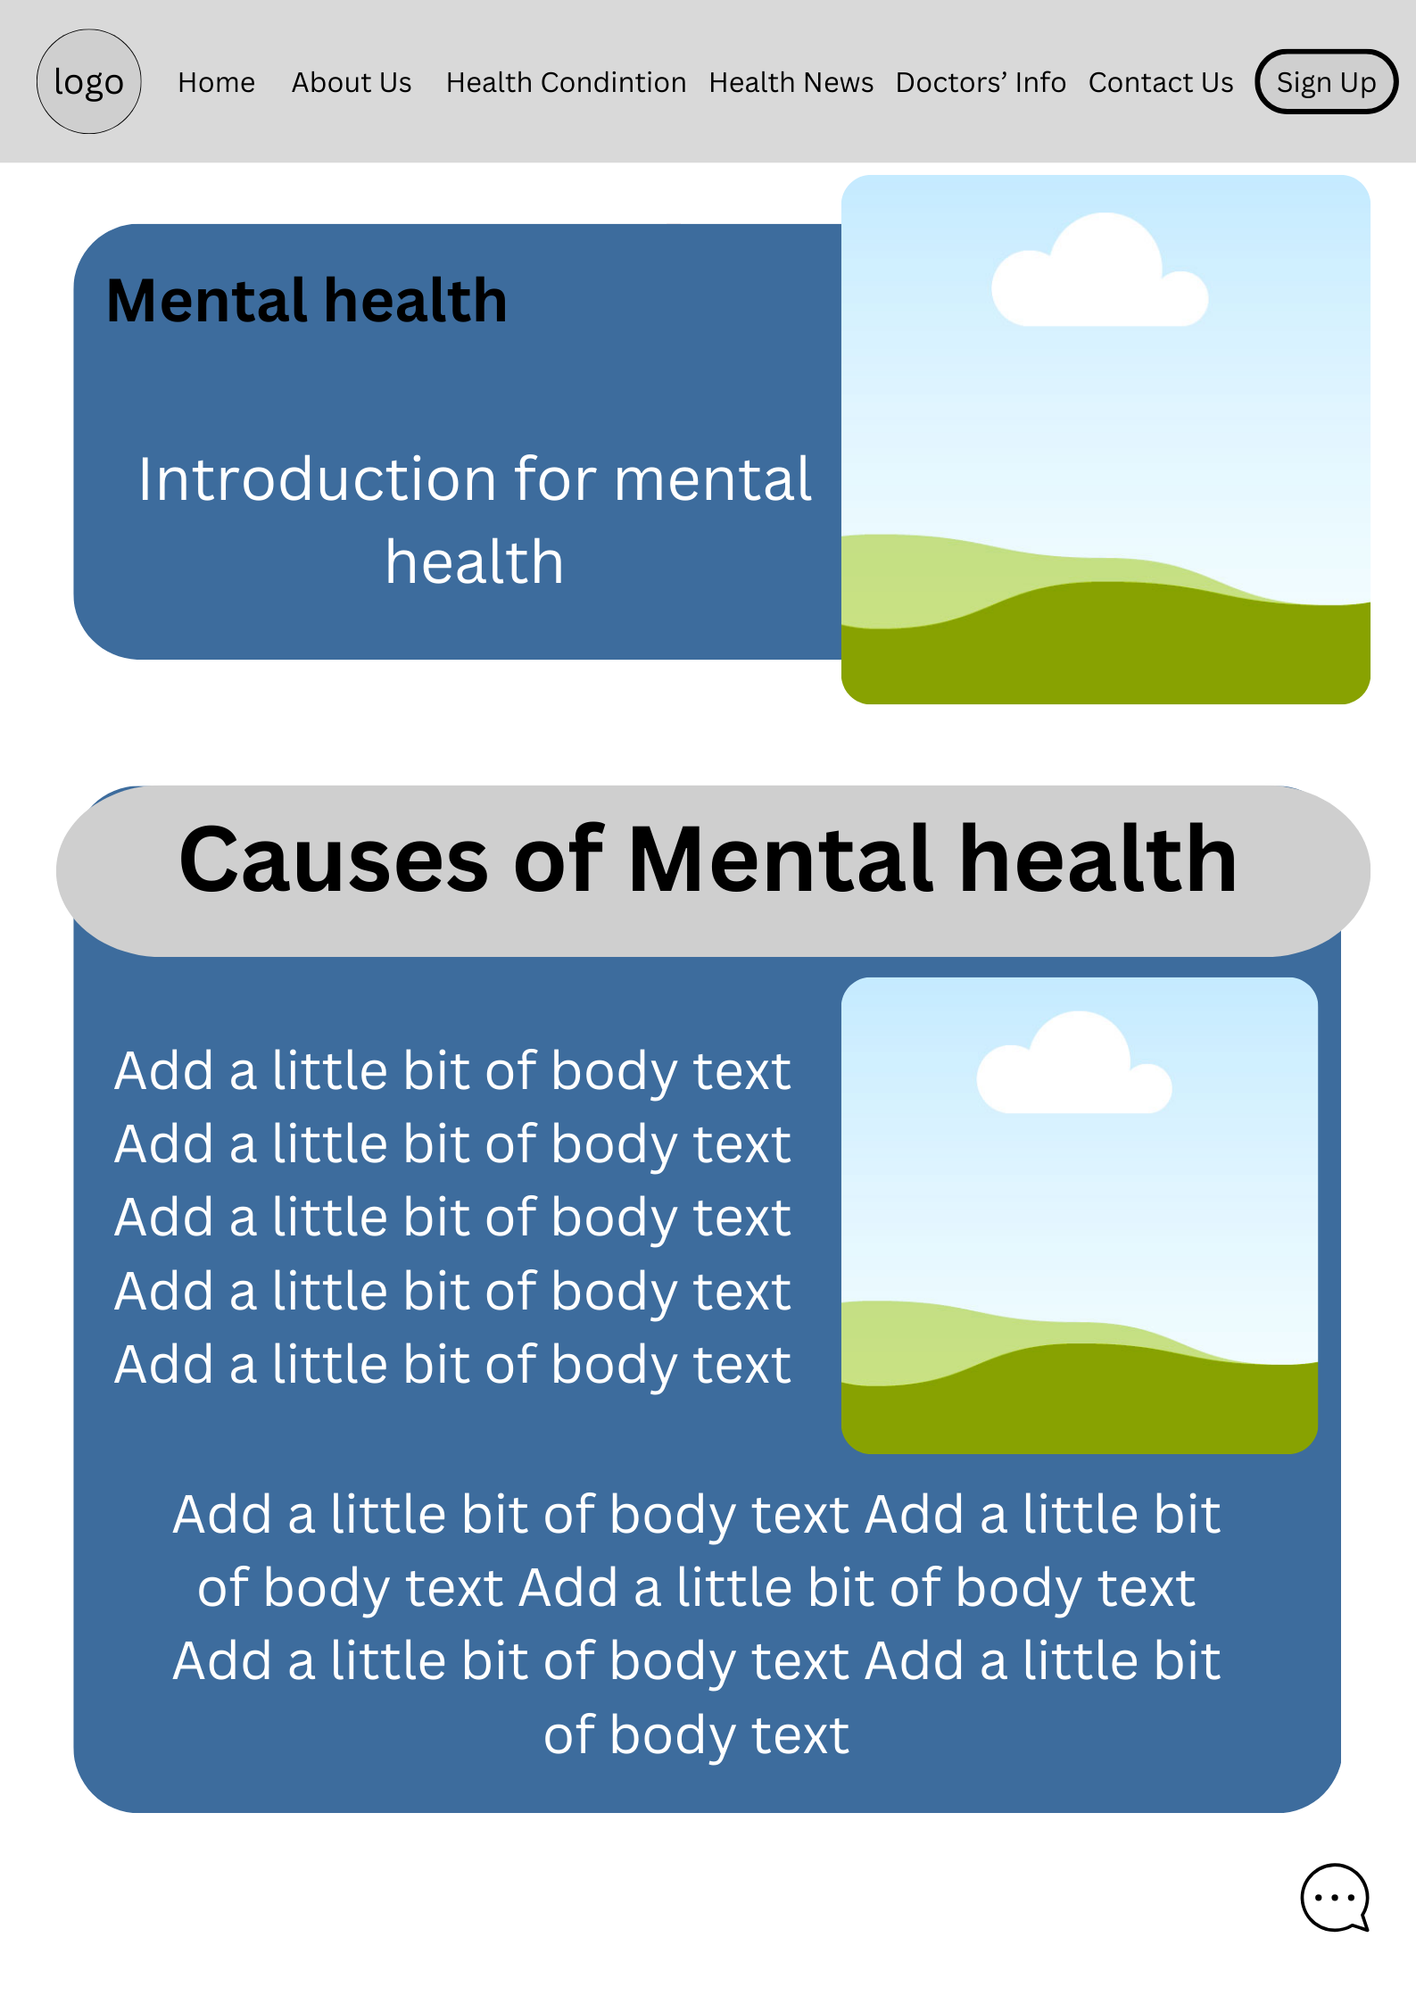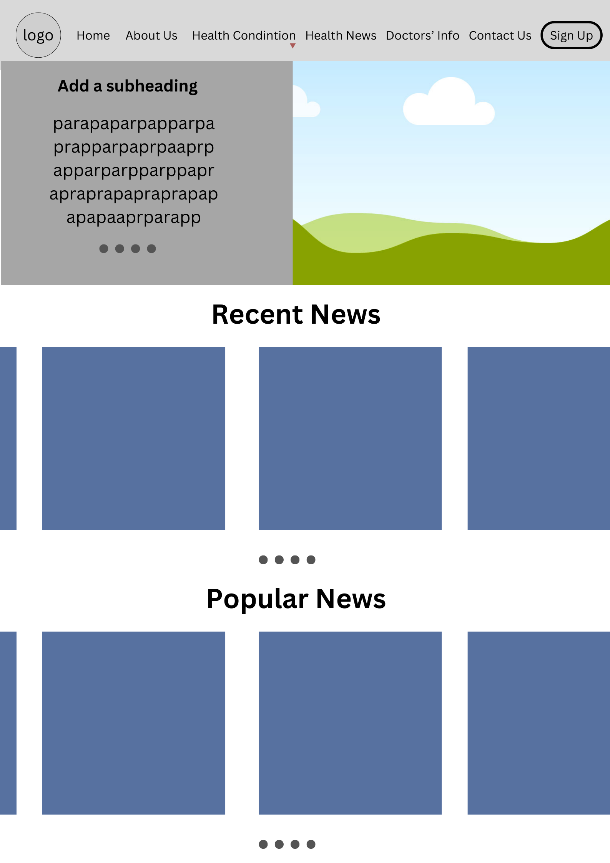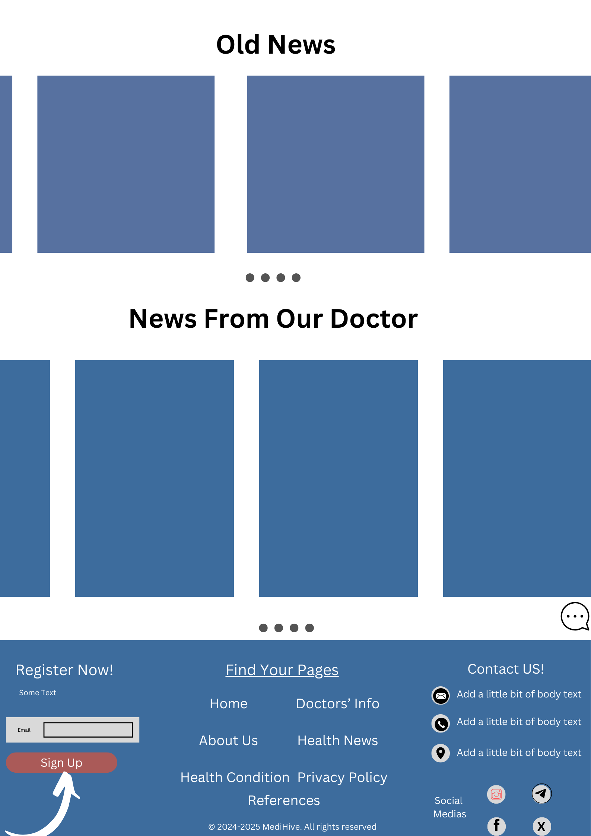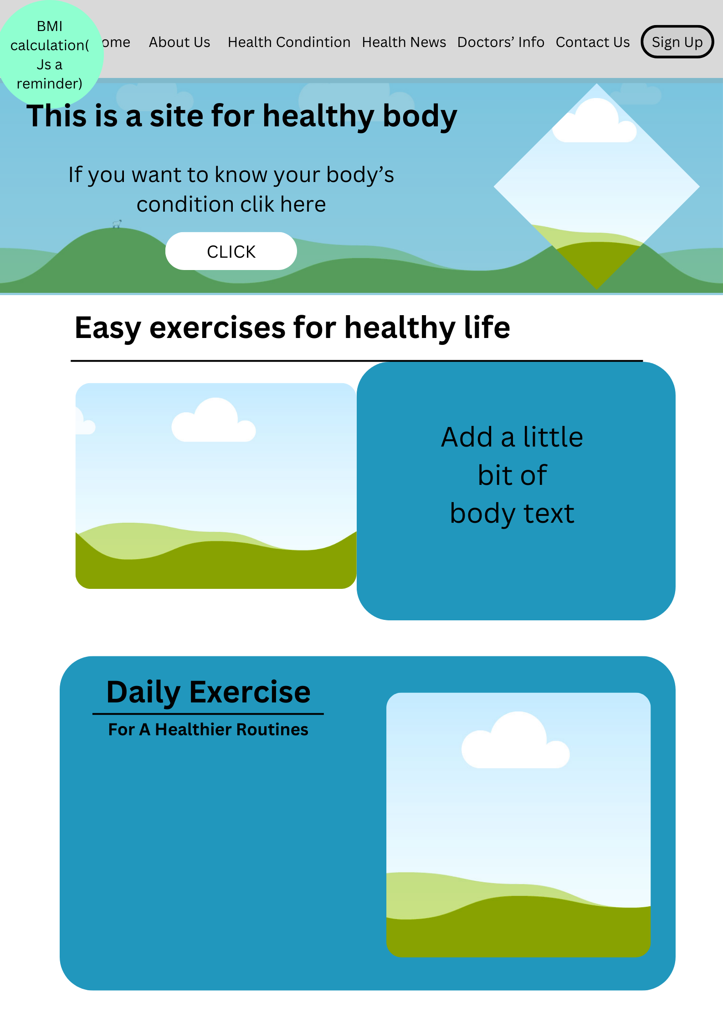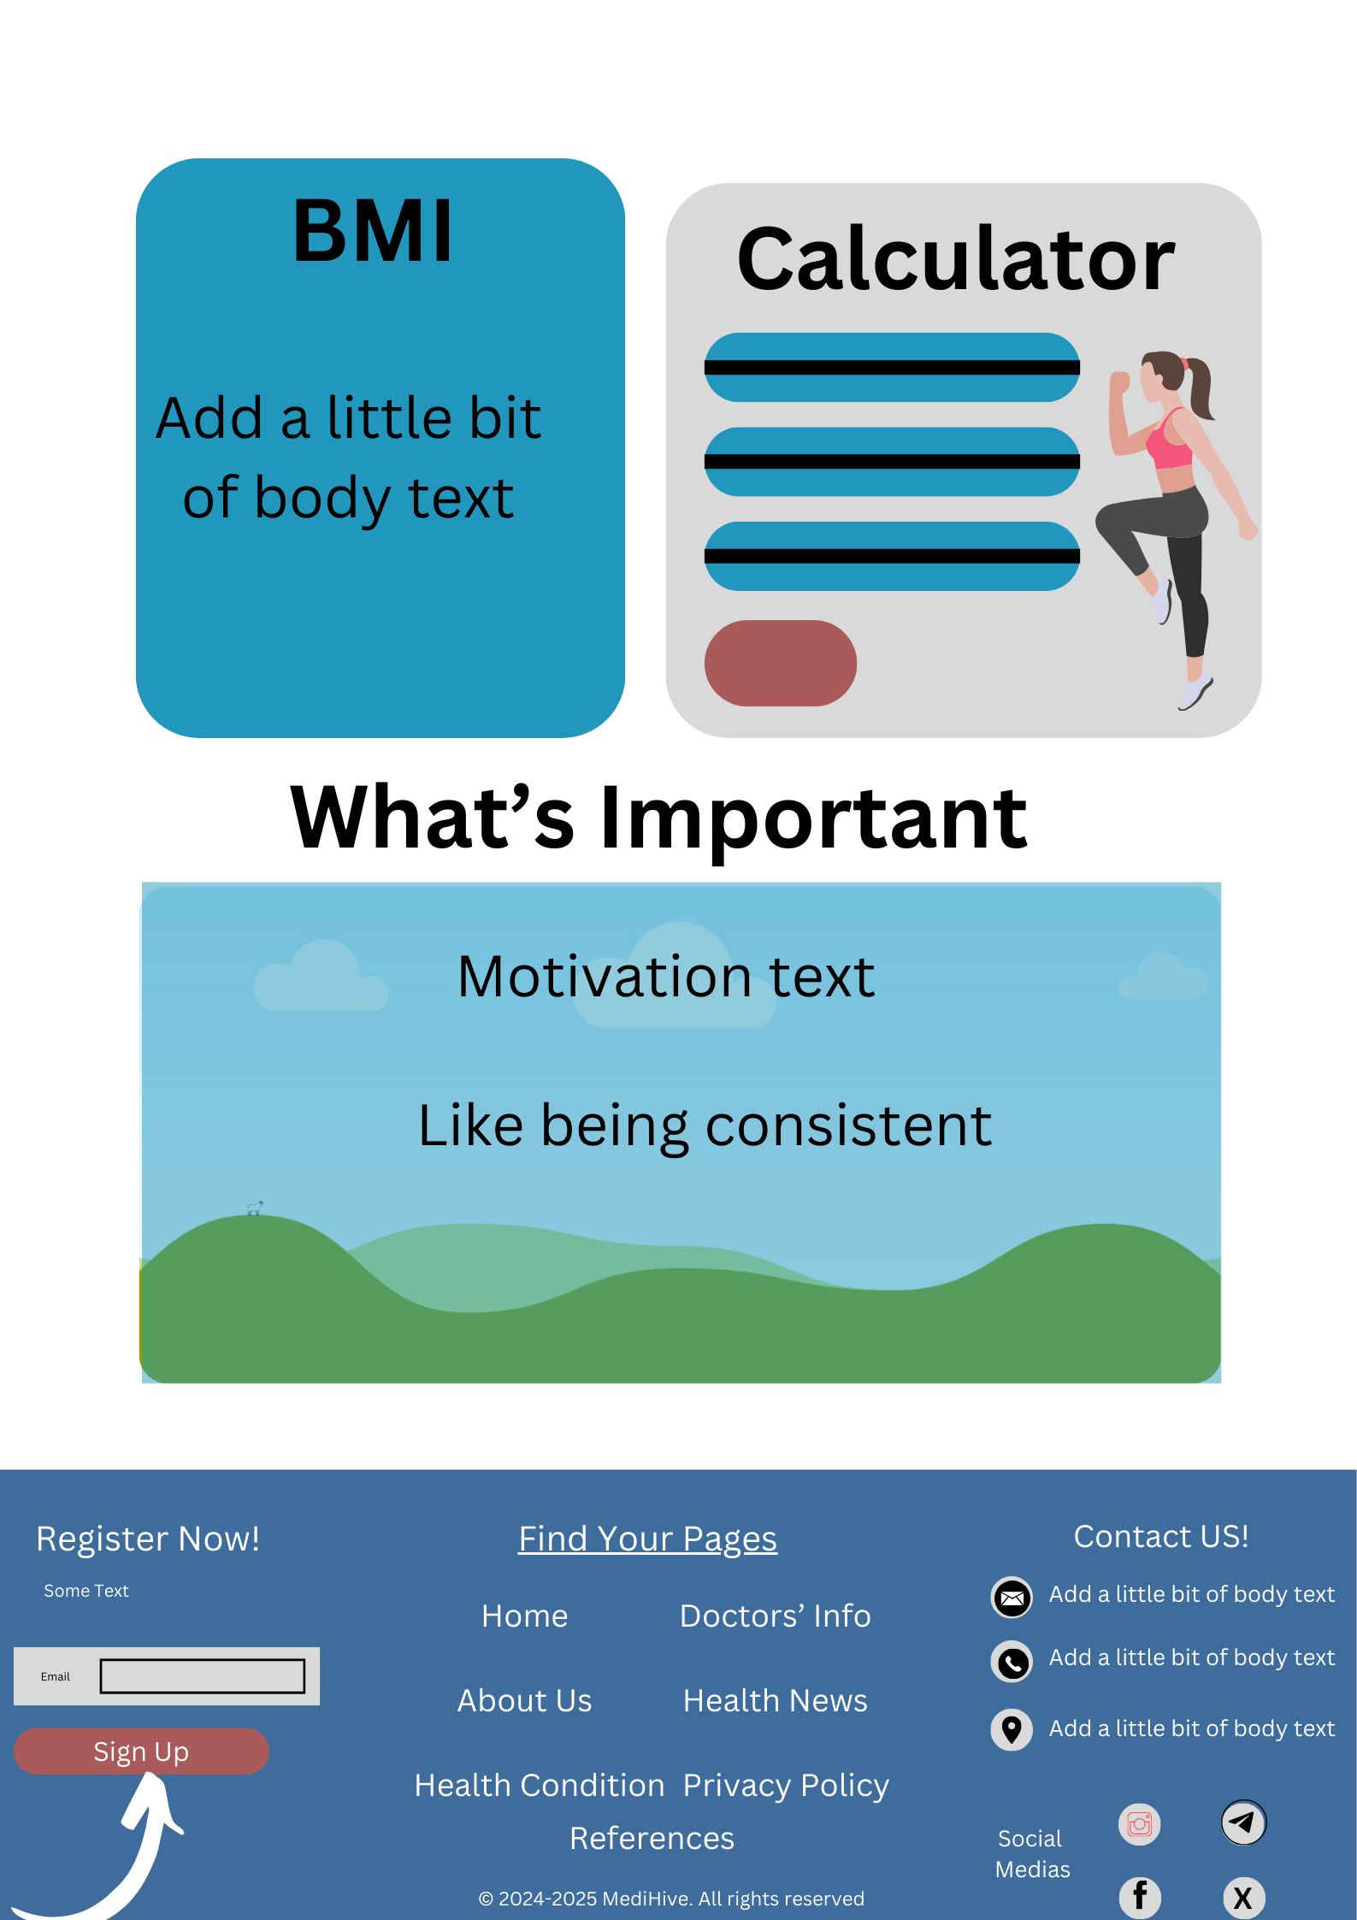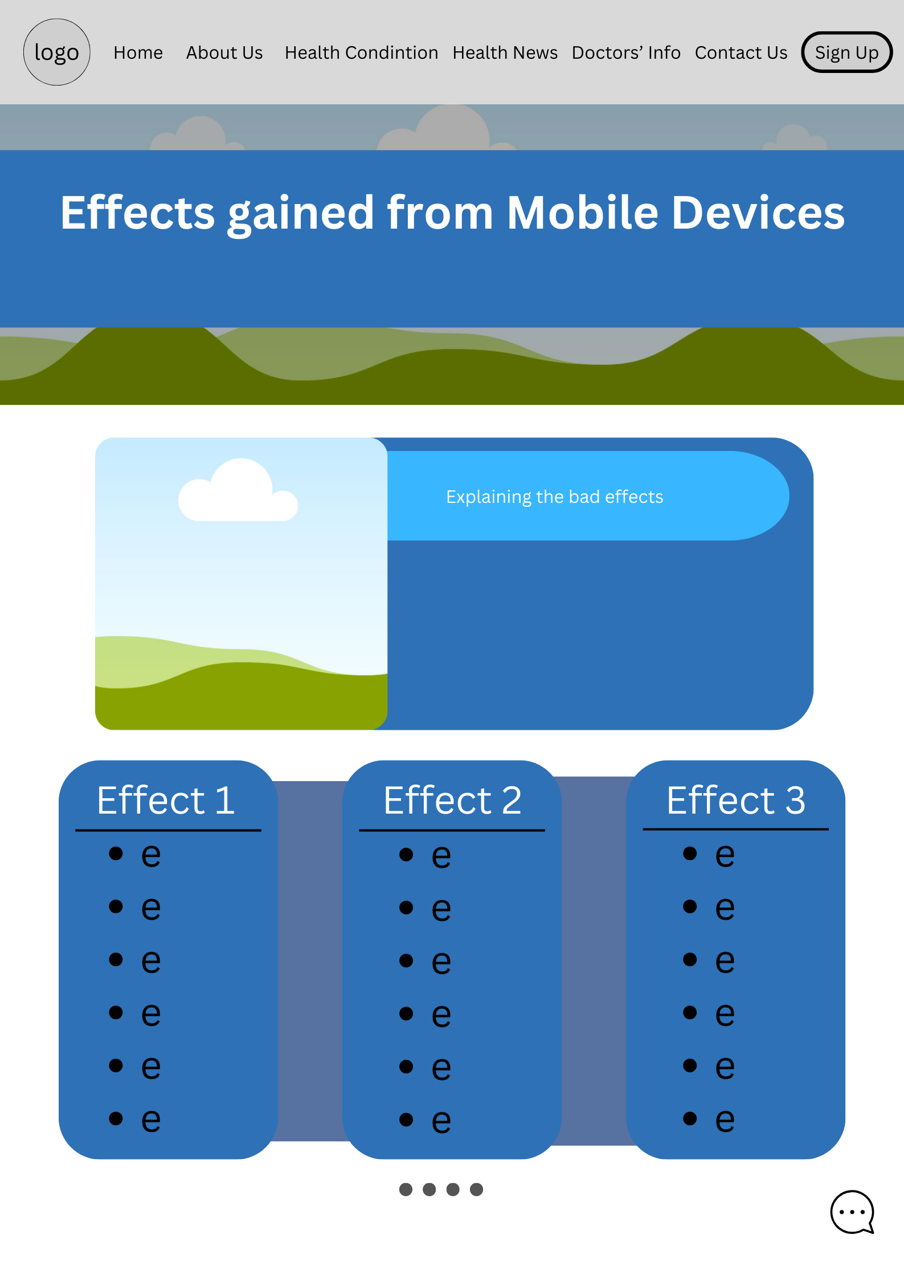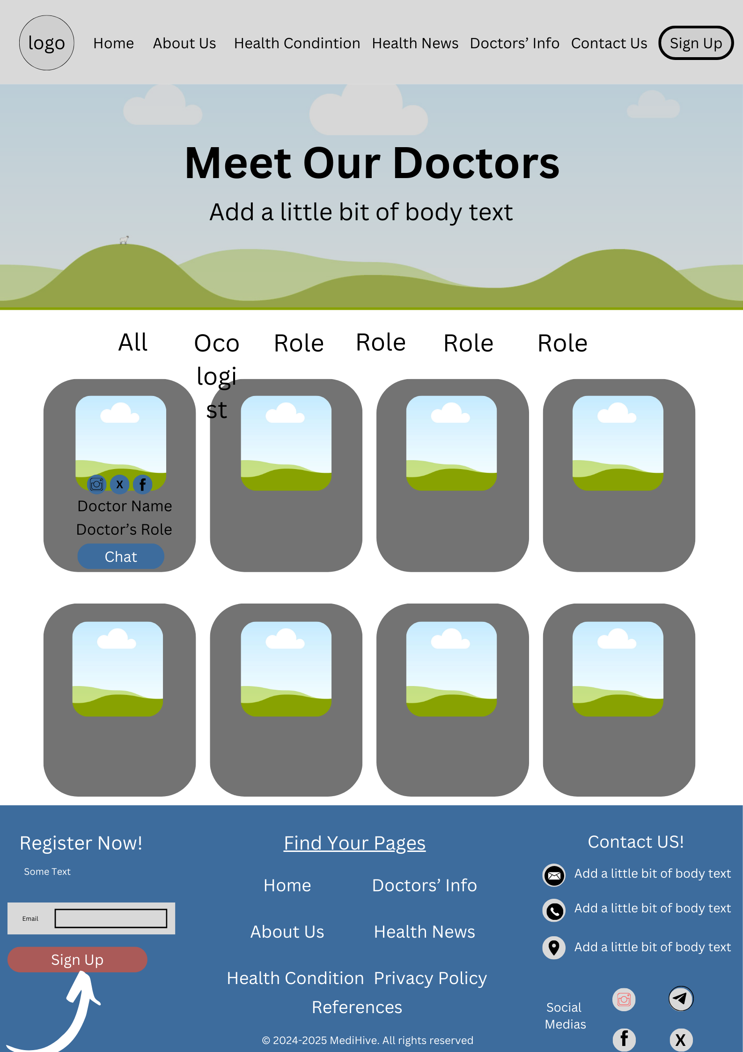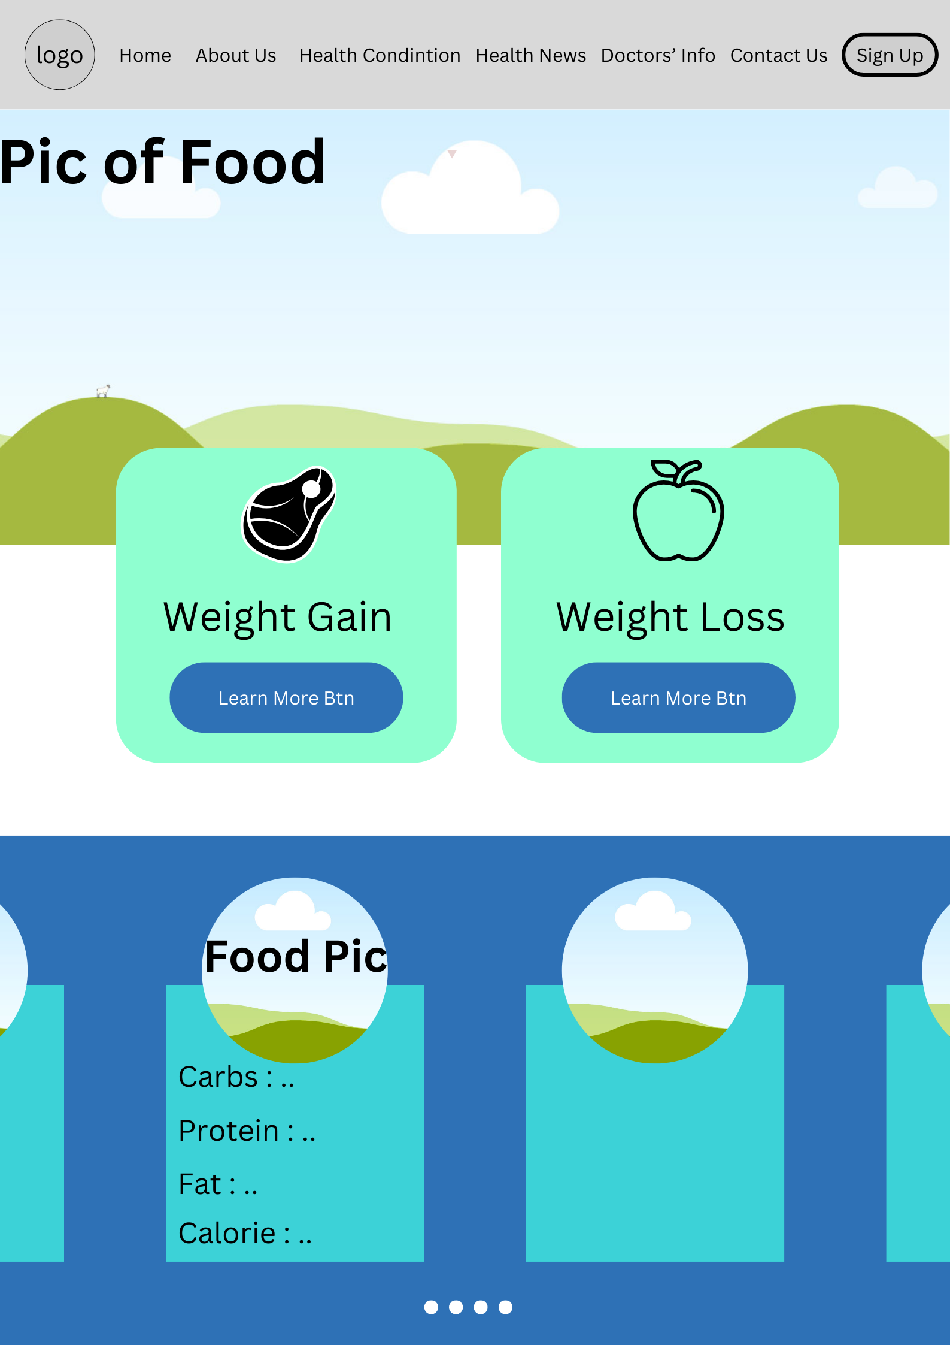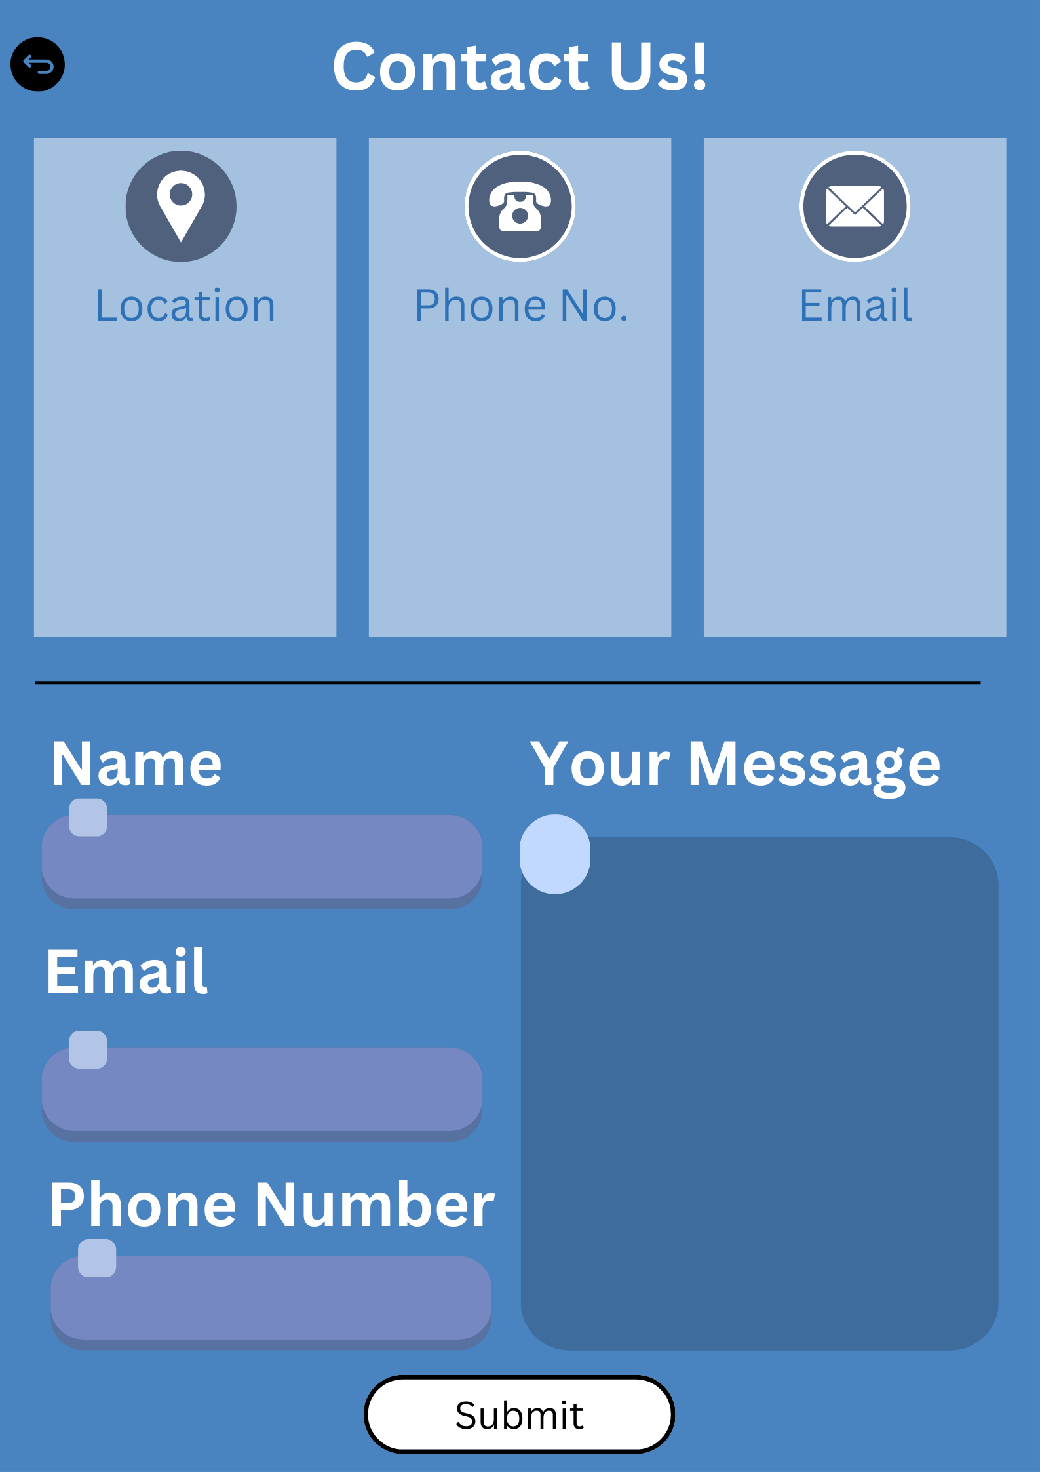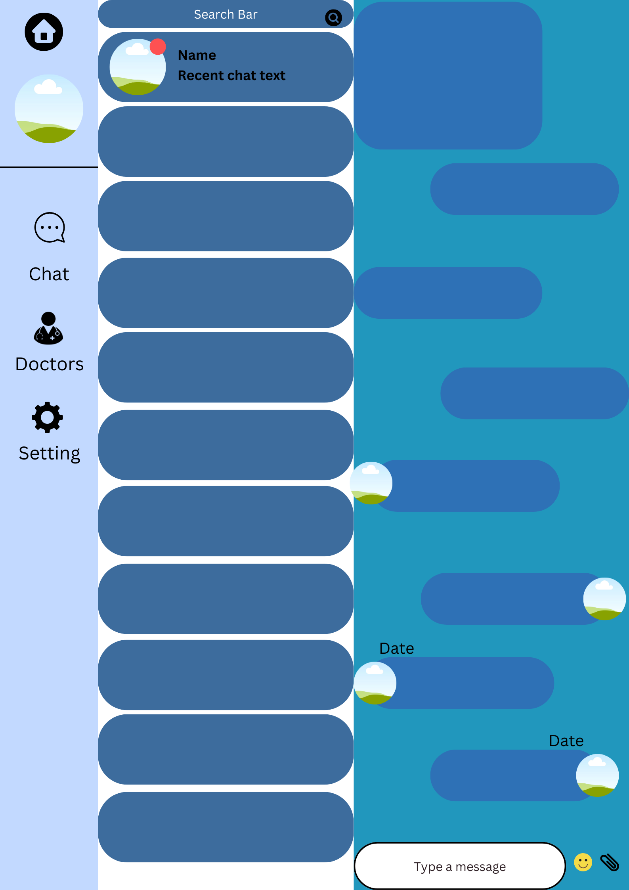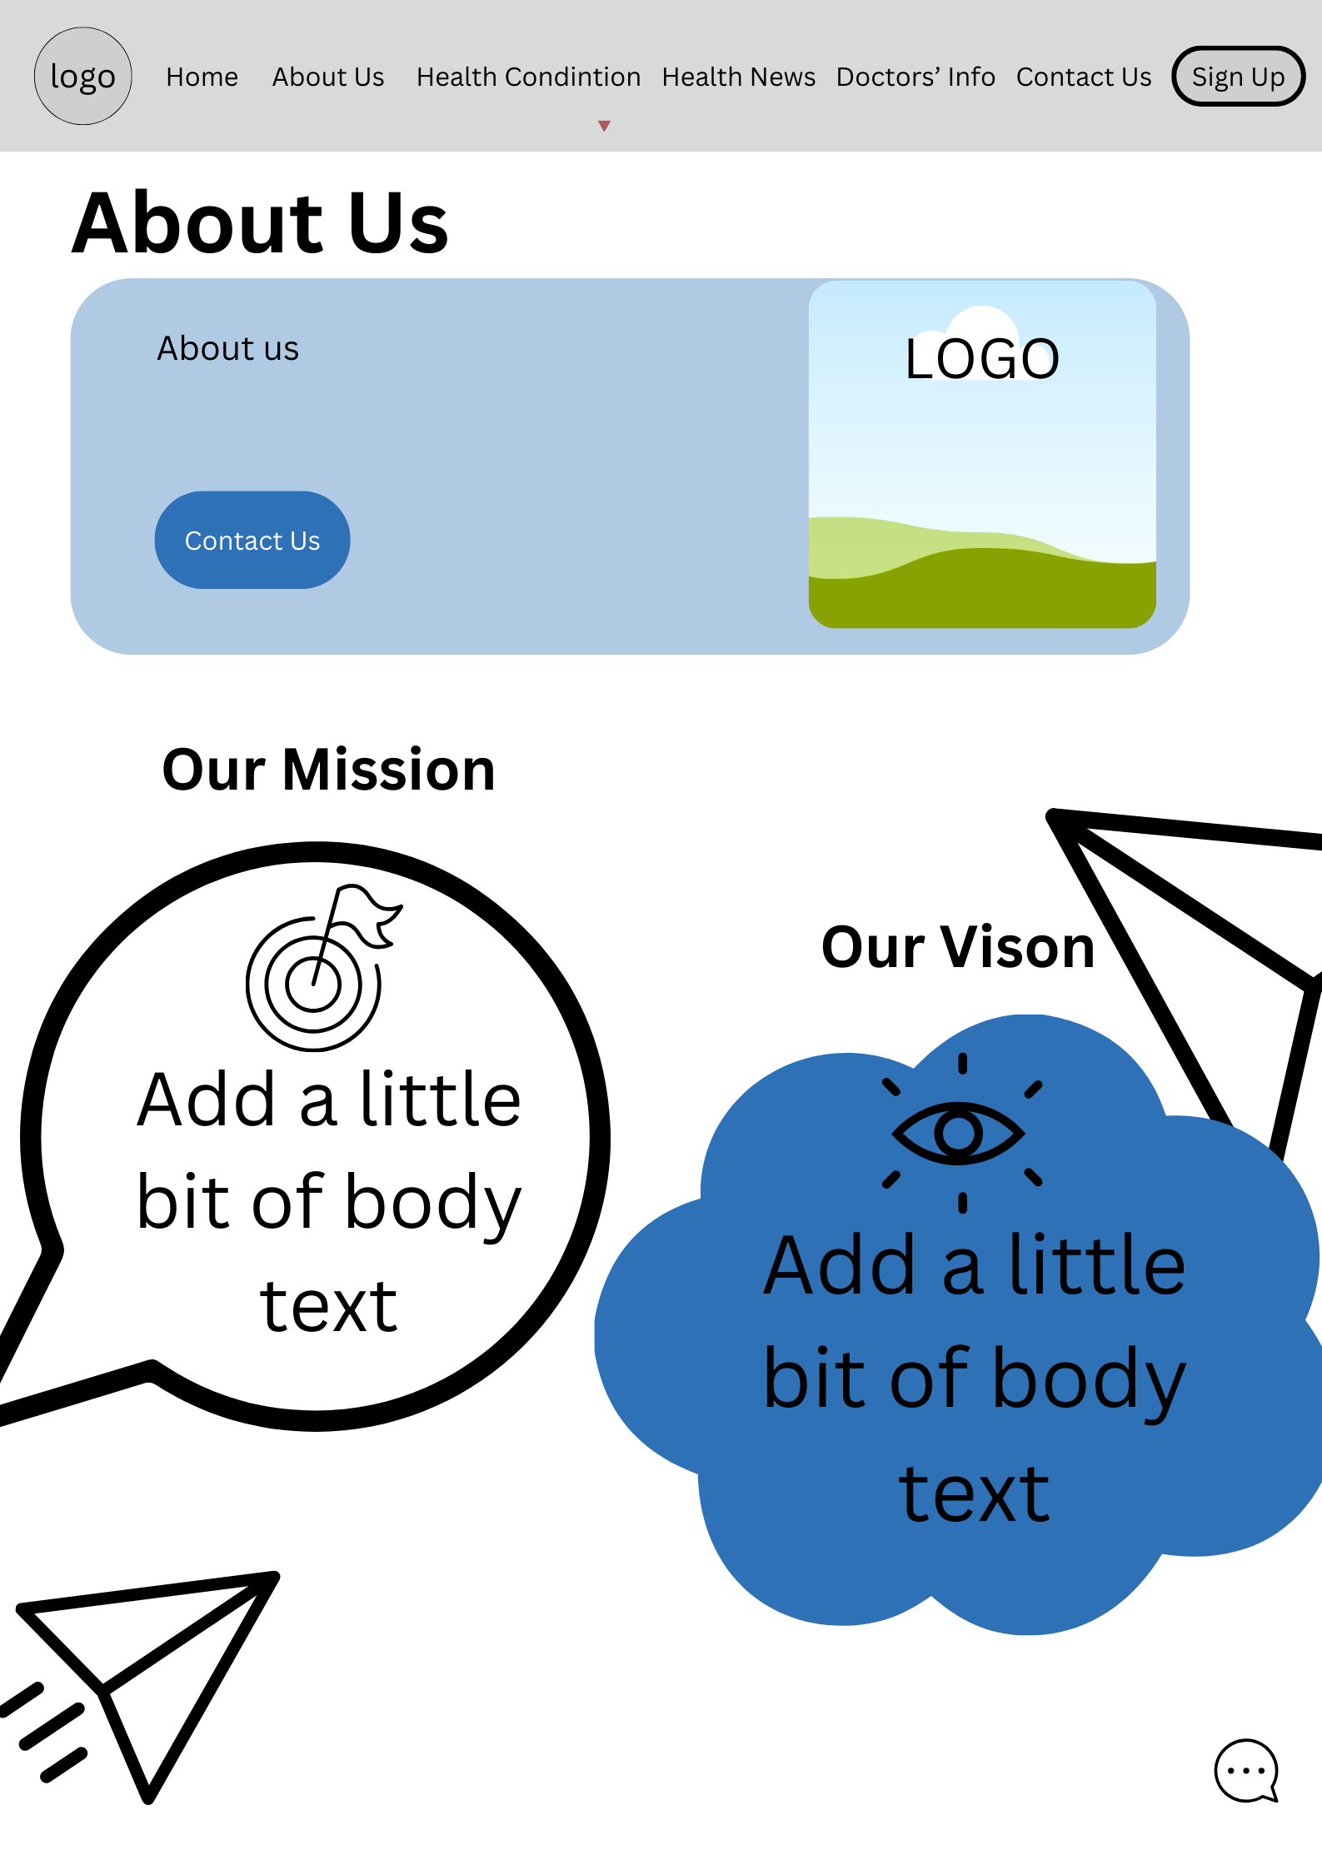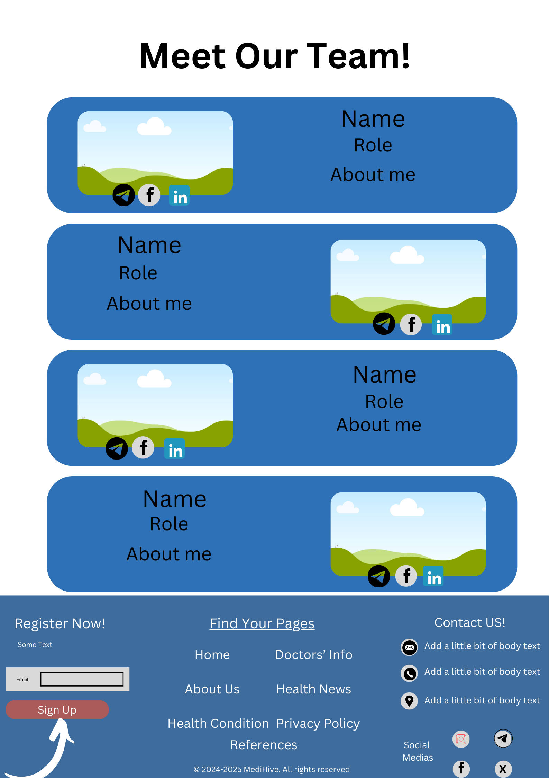References

For information:

* <https://www.healthline.com/>
* <https://www.medscape.com/>
* <https://dph.illinois.gov/topics-services/diseases-and-conditions/diseases-a-z-list.html>
* <https://uhs.princeton.edu/health-resources/common-illnesses>
* <https://medlineplus.gov/woundsandinjuries.html#:~:text=They%20include%20cuts%2C%20scrapes%2C%20scratches,is%20important%20to%20clean%20them>.
* <https://www2.hse.ie/conditions/common-illnesses/>
* <https://www.bliss.org.uk/parents/about-your-baby/common-infectious-illnesses/what-are-the-most-common-infectious-illnesses>
* <https://www.mayoclinic.org/>
* <https://www.muhealth.org/conditions-treatments/medicine/infectious-disease/seasonal-illnesses>
* <https://www.rainbowpeds.net/an-in-depth-look-at-the-seasonal-illnesses-going-around/>
* <https://www.healthlinkbc.ca/common-illnesses-and-injuries-during-winter>
* <https://www.asiaroyalhospital.com/>
* <https://www.health.harvard.edu/staying-healthy/5-of-the-best-exercises-you-can-ever-do>
* <https://www.healthline.com/health/fitness-exercise/10-best-exercises-everyday#how-to-improve>
* <https://www.google.com/url?sa=t&rct=j&q=&esrc=s&source=web&cd=&cad=rja&uact=8&ved=2ahUKEwio0baY5q6JAxW4R2wGHRTxMX4QFnoECCIQAQ&url=https%3A%2F%2Fwww.medicalnewstoday.com%2F&usg=AOvVaw0Cqem_egD6Th75A7owvJeJ&opi=89978449>
* <https://www.google.com/url?sa=t&rct=j&q=&esrc=s&source=web&cd=&cad=rja&uact=8&ved=2ahUKEwio0baY5q6JAxW4R2wGHRTxMX4QFnoECCAQAQ&url=https%3A%2F%2Fwww.bbc.com%2Fnews%2Fhealth&usg=AOvVaw1gxIVmt_-P9M_QyPf1b1WR&opi=89978449>
* <https://www.google.com/url?sa=t&rct=j&q=&esrc=s&source=web&cd=&cad=rja&uact=8&ved=2ahUKEwio0baY5q6JAxW4R2wGHRTxMX4QFnoECDAQAQ&url=https%3A%2F%2Fwww.cnn.com%2Fhealth&usg=AOvVaw1YsrdOg7MLN_OH1ivbppqh&opi=89978449>
* <https://www.google.com/url?sa=t&rct=j&q=&esrc=s&source=web&cd=&cad=rja&uact=8&ved=2ahUKEwiY7uGO666JAxWwcGwGHUVFMFAQFnoECCEQAQ&url=https%3A%2F%2Fwww.who.int%2Fnews-room%2Ffact-sheets%2Fdetail%2Fmental-disorders&usg=AOvVaw3vyhOh1MtUQsiTYPgW58vu&opi=89978449>
* <https://www.google.com/url?sa=t&rct=j&q=&esrc=s&source=web&cd=&cad=rja&uact=8&ved=2ahUKEwiY7uGO666JAxWwcGwGHUVFMFAQFnoECCIQAQ&url=https%3A%2F%2Fwww.medicalnewstoday.com%2Farticles%2F154543&usg=AOvVaw2tAFOdUA7UEE8a-jqfq9za&opi=89978449>
* <https://www.googleadservices.com/pagead/aclk?sa=L&ai=DChcSEwjrru_d666JAxVQIoMDHWEkAW8YABAAGgJzZg&ae=2&co=1&gclid=CjwKCAjwyfe4BhAWEiwAkIL8sIr5zNs213QY7ZmFbuBvXuiYpdtR-01m3bDj4_dcyiJ7KHzrLUPQvBoCtCYQAvD_BwE&ohost=www.google.com&cid=CAESVeD2K2_tKb0GaFX__sqX67Iw44lxmdO3f0d-7YHVpRmA59W648tp-Vj_jxyxuye-AP7F4i7enHWzmnBS_clci83LJxQ36IlaP_AsC5WNJGQpfopixjQ&sig=AOD64_2wGpyUUWkEsh0pP5cJApgBNeieWg&q&adurl&ved=2ahUKEwiCuerd666JAxVCR2wGHVI1Fh8Q0Qx6BAg2EAE>
* <https://www.google.com/url?sa=t&rct=j&q=&esrc=s&source=web&cd=&cad=rja&uact=8&ved=2ahUKEwiCuerd666JAxVCR2wGHVI1Fh8QFnoECBQQAQ&url=https%3A%2F%2Fmhanational.org%2F31-tips-boost-your-mental-health&usg=AOvVaw0YwTwRGPZR3nR0KDbeLqBg&opi=89978449>
* <https://www.google.com/url?sa=t&rct=j&q=&esrc=s&source=web&cd=&cad=rja&uact=8&ved=2ahUKEwimt-a56a6JAxVJQ2cHHb2gCZUQFnoECBsQAQ&url=https%3A%2F%2Fwww.healthline.com%2Fnutrition%2F27-health-and-nutrition-tips&usg=AOvVaw2kIu6-lDtUvJmt_qjhVwXa&opi=89978449>
* <https://www.google.com/url?sa=t&rct=j&q=&esrc=s&source=web&cd=&cad=rja&uact=8&ved=2ahUKEwimt-a56a6JAxVJQ2cHHb2gCZUQFnoECBgQAQ&url=https%3A%2F%2Ffairbanks.indianapolis.iu.edu%2Fdoc%2F10-Tips-Healthy-Lifestyle.pdf&usg=AOvVaw2jnMzOGMNfxEt9jaibSWJy&opi=89978449>
* <https://www.google.com/url?sa=t&rct=j&q=&esrc=s&source=web&cd=&cad=rja&uact=8&ved=2ahUKEwimt-a56a6JAxVJQ2cHHb2gCZUQFnoECBoQAQ&url=https%3A%2F%2Fwww.ucsfhealth.org%2Feducation%2Ftips-for-staying-healthy&usg=AOvVaw3r1a7gEljPsOOu1LqsT9z4&opi=89978449>
* <https://www.google.com/url?sa=t&rct=j&q=&esrc=s&source=web&cd=&cad=rja&uact=8&ved=2ahUKEwiCi6GD6q6JAxW8UGwGHd_sICwQFnoECBgQAQ&url=https%3A%2F%2Famberstudent.com%2Fblog%2Fpost%2F15-health-tips-for-students&usg=AOvVaw3v0PZ9E9tSH7nMmiGN6zzH&opi=89978449>
* <https://www.upmc.com/services/primary-care/conditions/minor-injuries>
* <https://www.google.com/url?sa=t&rct=j&q=&esrc=s&source=web&cd=&cad=rja&uact=8&ved=2ahUKEwikmbGj6K6JAxUO1zgGHYqOC5AQFnoECDMQAQ&url=https%3A%2F%2Fwww.who.int%2Fnews-room%2Ffact-sheets%2Fdetail%2Fhealthy-diet&usg=AOvVaw0DT-7msV3i-SK_3A9Li30J&opi=89978449>
* <https://www.google.com/url?sa=t&rct=j&q=&esrc=s&source=web&cd=&cad=rja&uact=8&ved=2ahUKEwjEs6fp6K6JAxXpxTgGHY5EJYgQFnoECB0QAQ&url=https%3A%2F%2Fwww.healthline.com%2Ffitness&usg=AOvVaw2IDdvJg7-ogpQncBaIKtjR&opi=89978449>
* <https://www.google.com/url?sa=t&rct=j&q=&esrc=s&source=web&cd=&cad=rja&uact=8&ved=2ahUKEwjEs6fp6K6JAxXpxTgGHY5EJYgQFnoECDgQAQ&url=https%3A%2F%2Fwww.everydayhealth.com%2Ffitness%2Fguide%2F&usg=AOvVaw33tI4Bs7EMpAx5-HPTHX-6&opi=89978449>
* <https://www.google.com/url?sa=t&rct=j&q=&esrc=s&source=web&cd=&cad=rja&uact=8&ved=2ahUKEwjEs6fp6K6JAxXpxTgGHY5EJYgQFnoECDIQAQ&url=https%3A%2F%2Fwww.mayoclinic.org%2Fhealthy-lifestyle%2Ffitness%2Fbasics%2Ffitness-basics%2Fhlv-20049447&usg=AOvVaw0zRr7BbfnEcfl4JG55yWL_&opi=89978449>
* <https://www.euronews.com/health/2024/10/23/green-space-in-cities-helps-mitigate-health-effects-of-extreme-heat-study-finds>
* <https://www.medicalnewstoday.com/articles/poor-sleep-brain-health-faster-aging-studies>
* <https://www.bbc.com/news/articles/c8dmp250zjno>
* <https://www.bbc.com/news/articles/c2060gy9zy1o>
* <https://www.bbc.com/news/articles/c20g7ve9z27o>
* <https://www.who.int/news-room/fact-sheets/detail/mental-disorders>
* <https://www.health.harvard.edu/staying-healthy/5-of-the-best-exercises-you-can-ever-do>
* <https://www.healthline.com/health/fitness-exercise/10-best-exercises-everyday#how-to-improve>
* [Thwin Moe Nyunt: https://neurologyoffice.com/wp-content/uploads/Carpal-Tunnel-Pain...](https://teams.microsoft.com/l/message/19:374b5ee35ad8495a99fdafe36c1a02d4@thread.v2/1733145136719?context=%7B%22contextType%22%3A%22chat%22%7D)
* <https://encrypted-tbn0.gstatic.com/images?q=tbn:ANd9GcQFH81nEuUUQoloyBDNysSCXP9Pg5VJ-nyPww&s>
* <https://www.nardelliaudiologists.com/blog/images/hearing-damage-in-the-workplace.jpg>
* <https://blog.encompasshealth.com/wp-content/uploads/2021/03/Cyberchondria.jpg>
* <https://encrypted-tbn0.gstatic.com/images?q=tbn:ANd9GcQPO2k13zjpJ2fHzfzc3Mxs-yxBE6xMz4jibA&s>
* <https://encrypted-tbn0.gstatic.com/images?q=tbn:ANd9GcRK6JjRcgYoPvv0gy6ugodu7KoeZ8q7ndnveA&s>
* <https://encrypted-tbn0.gstatic.com/images?q=tbn:ANd9GcSn-vsFgP5CdM3PKdpTvvWXVlpQ_HSLb6KmYw&s>
* <https://www.eatingwell.com/>
* <https://www.bhg.com/>
* <https://www.healthline.com/nutrition/how-to-gain-weight>
* <https://www.medicalnewstoday.com/articles/322345#intermittent-fasting>
* <https://downshiftology.com/>
* <https://www.tasteofhome.com/>

For designs and decoration:

* <https://piktochart.com/tips/medical-color-palette>



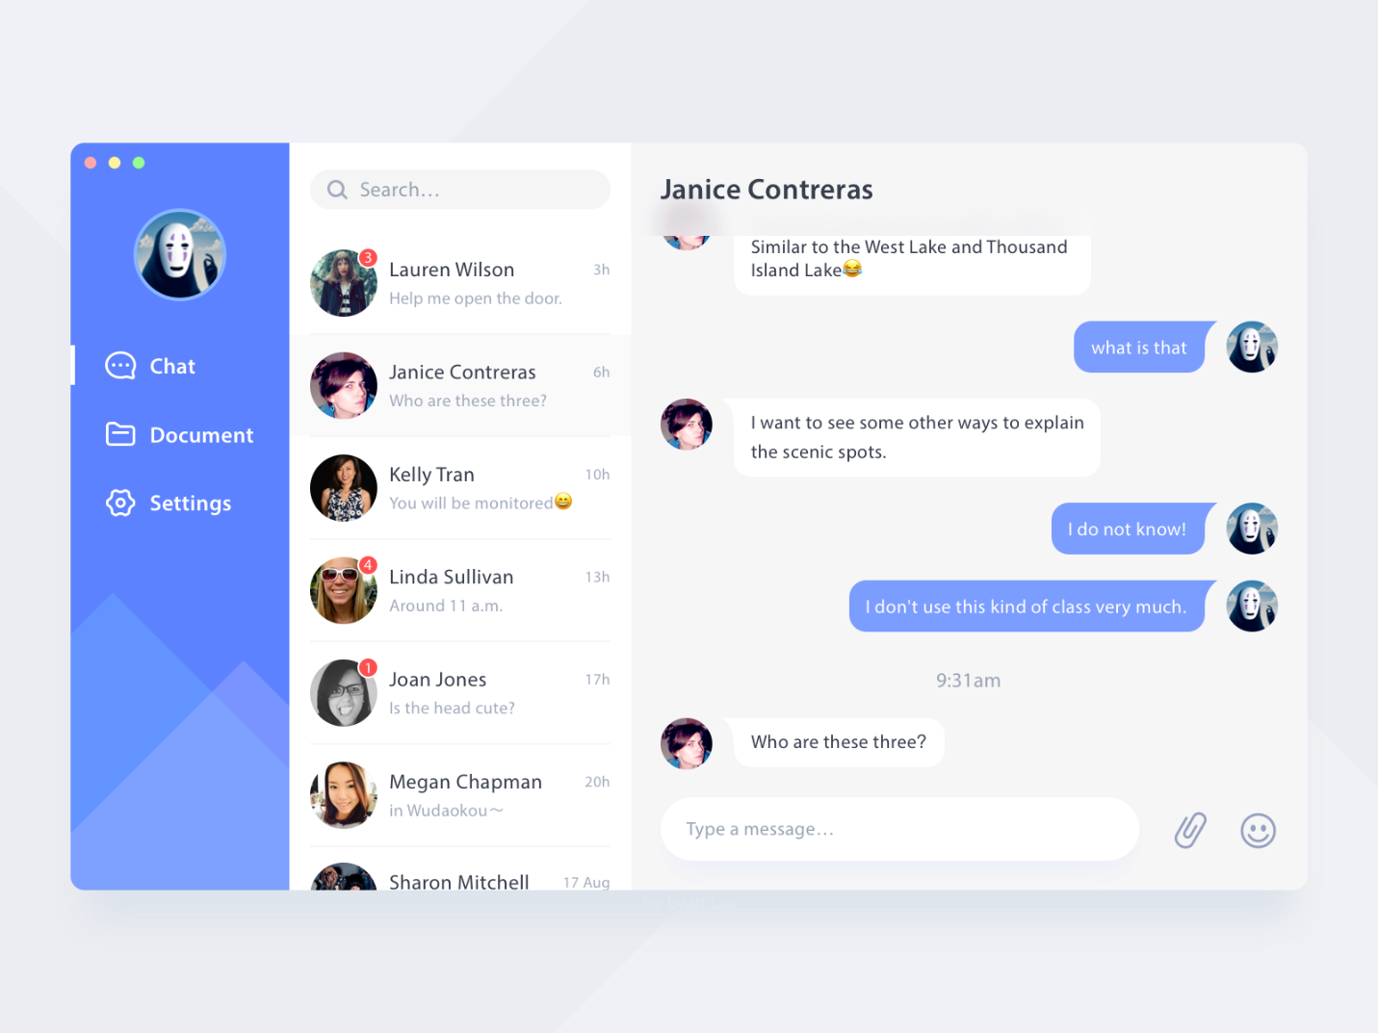



Images:

* <https://pin.it/YgbQdv3dj>
* <https://pin.it/1GtJQhCO2>
* <https://www.istockphoto.com/photos/multiple-doctors>
* <https://images.app.goo.gl/SdJFxHpiUEiZ5SjG9>
* <https://images.app.goo.gl/B4f8e72AiLJsawPS8>
* <https://www.google.com/url?sa=i&url=https%3A%2F%2Feleks.com%2Ftypes-of-software-development%2Fmaintenance-and-support-services-in-it%2F&psig=AOvVaw1M-nIkfsrZxPAPjMnrh47N&ust=1731559692660000&source=images&cd=vfe&opi=89978449&ved=0CBQQjRxqFwoTCPDv4NjA2IkDFQAAAAAdAAAAABAE>
* <https://www.google.com/url?sa=i&url=https%3A%2F%2Fwww.raymond.in%2Fcontact-us&psig=AOvVaw26dr3hdbEEP7_ImiVr1ADT&ust=1731561273561000&source=images&cd=vfe&opi=89978449&ved=0CBQQjRxqFwoTCPCe6czG2IkDFQAAAAAdAAAAABAJ>
* <https://www.google.com/url?sa=i&url=https%3A%2F%2Ficonscout.com%2Fillustrations%2Fcontact-us&psig=AOvVaw0T0D382ZcTSDoihmO380cO&ust=1731561792977000&source=images&cd=vfe&opi=89978449&ved=0CBQQjRxqFwoTCIiVzMLI2IkDFQAAAAAdAAAAABAE>
* <https://static.vecteezy.com/system/resources/previews/024/801/641/non_2x/anxiety-disorder-illustration-vector.jpg>
* <https://encrypted-tbn0.gstatic.com/images?q=tbn:ANd9GcQnK6ipN7C33Cox6cJ1zSDy5lR1WnpxZPpyEA&s>
* <https://encrypted-tbn0.gstatic.com/images?q=tbn:ANd9GcSgCd9C3s1HG3-jZBI-Y7YXfeJNnm1l0_d81w&s>
* <https://vrindavanchikitsalayam.com/wp-content/uploads/2023/12/WhatsApp-Image-2023-12-19-at-1.03.45-PM-1024x683.jpeg>
* <https://media1.tenor.com/m/IpT37hF7X0YAAAAd/you-didnt-have-to-cut-me-off-meme-you-didnt-have-to-cut-me-off.gif>
* <https://adhdta.com.au/wp-content/uploads/2023/09/adult-adhd-assessment-treatment.png>
* <https://encrypted-tbn0.gstatic.com/images?q=tbn:ANd9GcRctqafblXgRT2MjGhb2gRQsENiiotIYw9qdw&s>
* <https://www.sovahealthcare.co.uk/wp-content/uploads/2021/10/DEMENTIA-MEMORY-LOSS-1.jpg>
* <https://www.google.com/url?sa=i&url=https%3A%2F%2Fstock.adobe.com%2Fsearch%2Fimages%3Fk%3Dbanner%2Bgym&psig=AOvVaw0fQIDyNJsnmzjwtb8HuZ1H&ust=1732272318929000&source=images&cd=vfe&opi=89978449&ved=0CBQQjRxqFwoTCPC117-f7YkDFQAAAAAdAAAAABAo>
* <https://images.app.goo.gl/rL1W4dRmhhxJBpAF8>
* <https://images.app.goo.gl/S7784Un33HJbqhyw9>